5. Git-HOL
Objectives
- Explain how to clean up and push back to remote Git
In this hands-on lab, you will learn how to:
- Execute steps involving clean up and push back to remote Git.
Prerequisites
The following are the pre-requisites to complete this hands-on lab:
- Hands-on ID: “Git-T03-HOL_002”
Implementation:

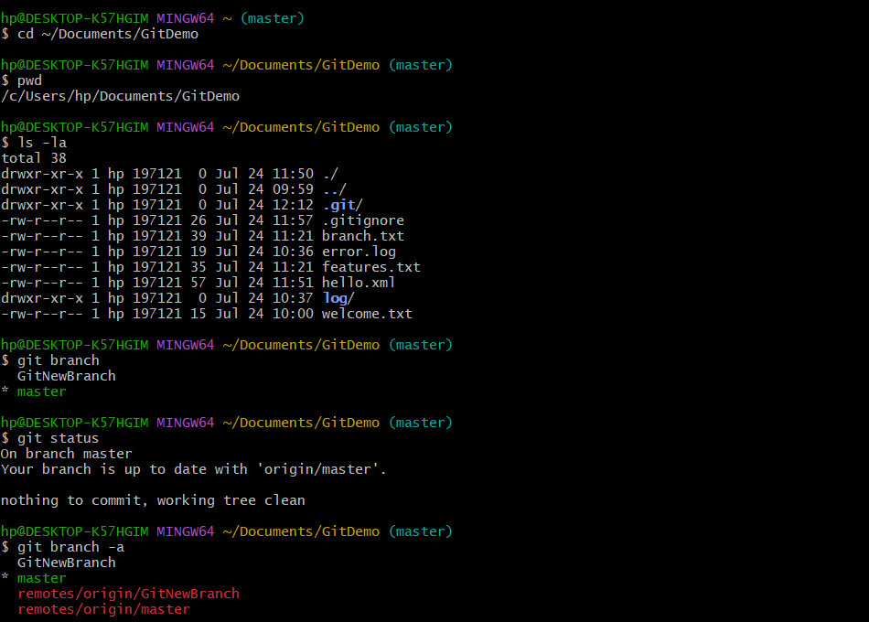

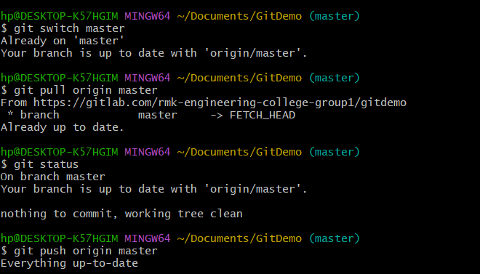

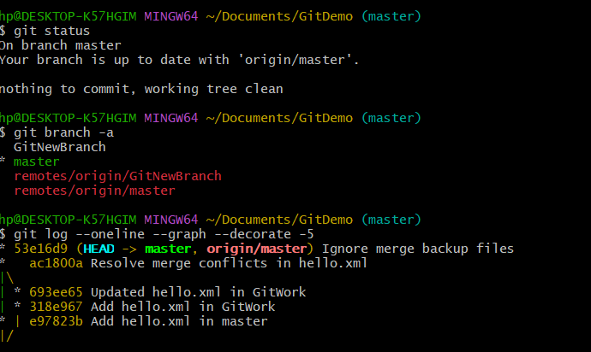

OUTPUT:

